# DIS-AM,C-Taino-Cohoba Receptacle Figure

# Cohoba cemi figurine used by the Tainó *behique* (shaman) during hallucinogenic rituals. Cohoba powder was placed on the disk above the figure’s head. Note that the figure is portrayed as being emaciated which is the stance that the *behique* must take to be in psychological attunement with his patient.

# 

# Order details

## Sales order

Sold by [guayacanex](http://myworld.ebay.com/guayacanex) ( [488](http://feedback.ebay.com/ws/eBayISAPI.dll?ViewFeedback&userid=guayacanex) )

### Delivery package 1 of 1

Estimated delivery Monday, Mar 7, 2016 - Wednesday, Mar 23, 2016

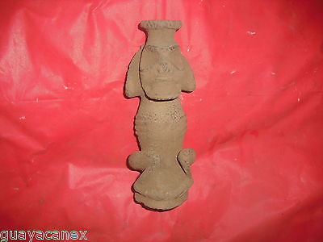

#### [Taino special Zemi of black stone in excellent condition](http://www.ebay.com/itm/231809832789)

|  |  |
| --- | --- |
| Item price | $299.00 |
| Quantity | 1 |
| Item number | 231809832789 |
| Shipping service | Economy Shipping |

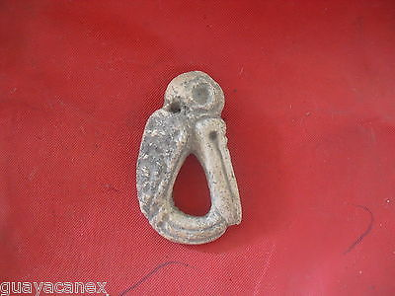

#### [Taino Manati bone bird amulet](http://www.ebay.com/itm/231809857445)

|  |  |
| --- | --- |
| Item price | $99.00 |
| Quantity | 1 |
| Item number | 231809857445 |
| Shipping service | Economy Shipping |